FORMING AND SOLVING EQUATIONS
OCR GSCE – Tuesday 21 May 2019 – Paper 4 (Calculator) Higher Tier
1.
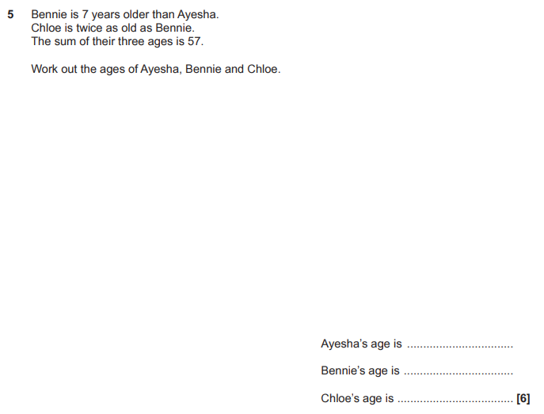

OCR GSCE – Thursday 24 May 2018 – Paper 4 (Calculator) Higher Tier
2.
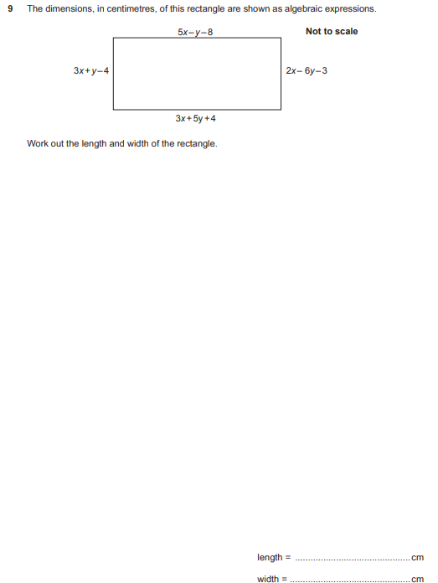

OCR GSCE – Tuesday 6 November 2017 – Paper 5 (Non - Calculator) Higher Tier
3.
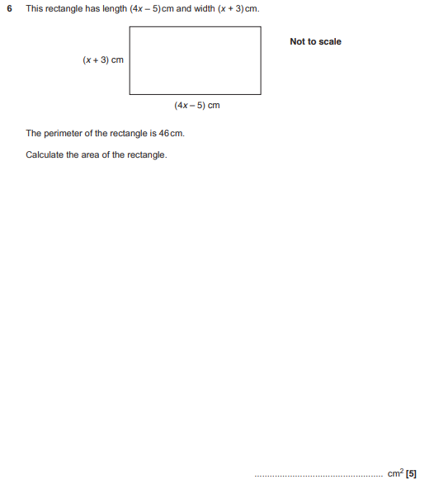

OCR GSCE – Wednesday 8 November 2017 – Paper 6 (Calculator) Higher Tier
4.
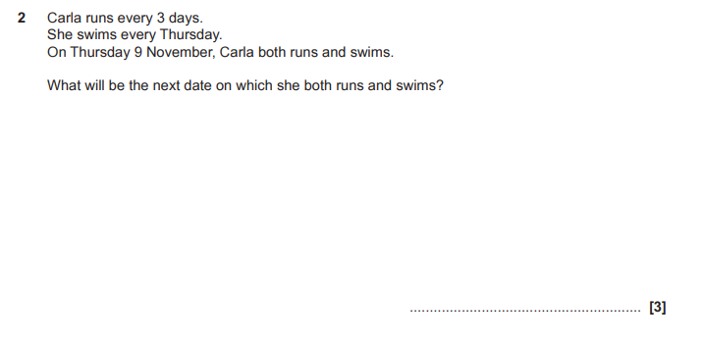

OCR GSCE – Thursday 25 May 2017 – Paper 4 (Calculator) Higher Tier
5.
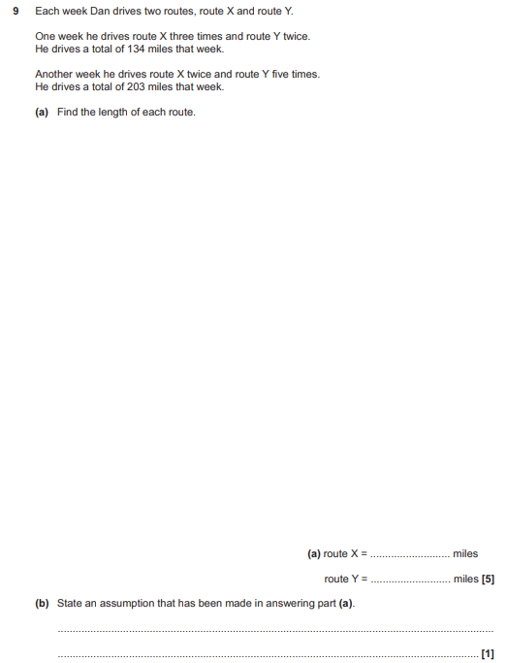

OCR GSCE – Sample Papers – Paper 4 (Calculator) Higher Tier
6.
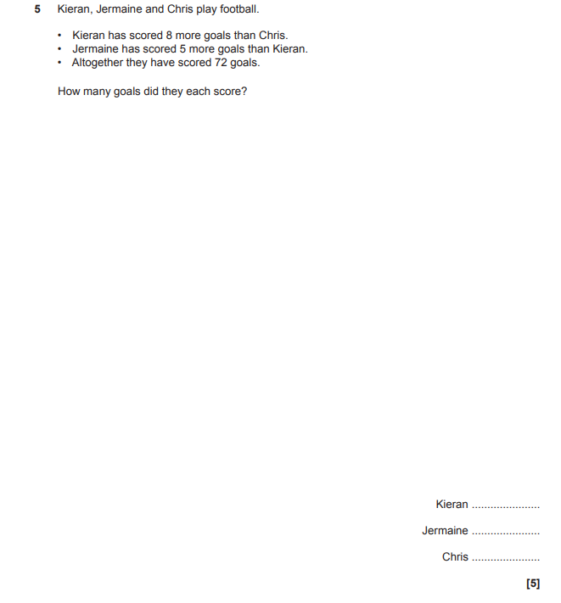

OCR GSCE – Sample Papers – Paper 5 (Non - Calculator) Higher Tier
7.
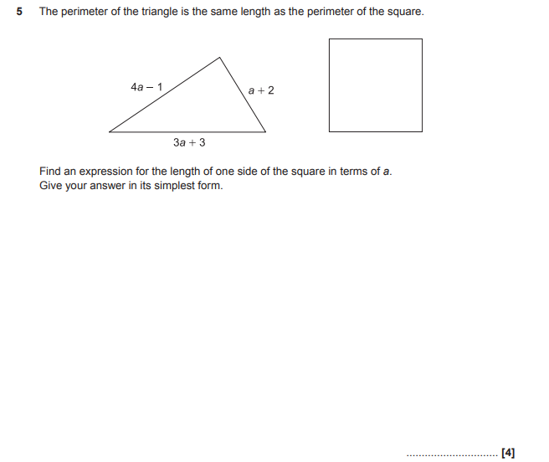

AQA GSCE – Tuesday 11 June 2019 – Paper 3 (Calculator) Higher Tier
8.
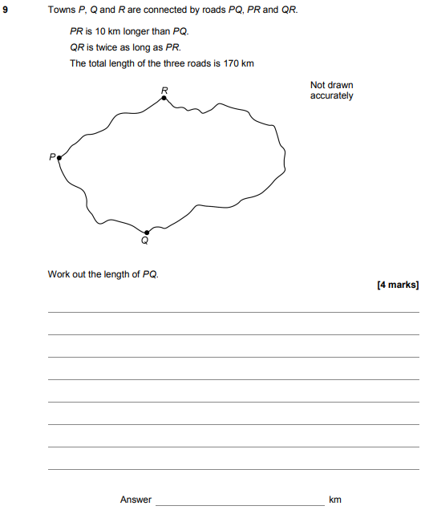

AQA GSCE – Tuesday 6 November 2018 – Paper 1 (Non - Calculator) Higher Tier
9.
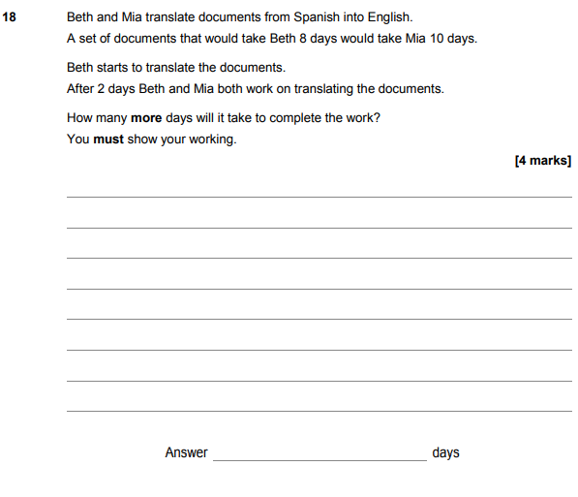

AQA GSCE – Thursday 8 November 2018 – Paper 2 (Calculator) Higher Tier
10.
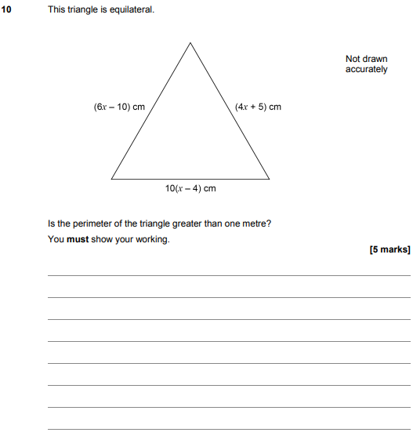

AQA GSCE – Thursday 6 November 2017 – Paper 2 (Calculator) Higher Tier
11.
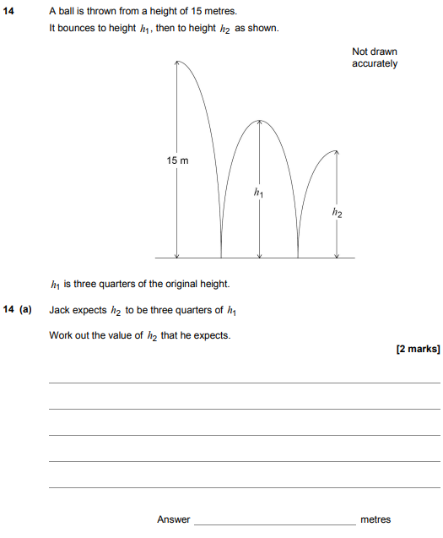
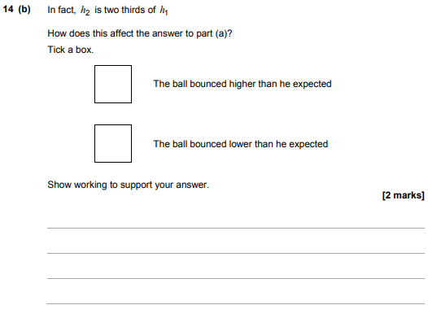

AQA GSCE – Wednesday 25 May 2017 – Paper 1 (Non - Calculator) Higher Tier
12.
